Networking-5
Three way handshake
Three-way handshake is a three-step process used by the TCP to set up a reliable connection between a client and a server before sending any actual data.
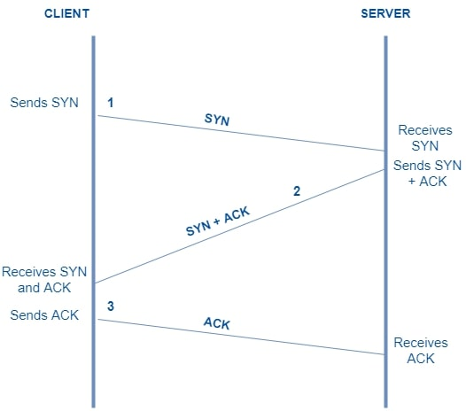

The 3 Steps of the Handshake
1. SYN (Synchronize)
- The client sends a segment with the SYN flag set to the server.
- It includes its chosen Initial Sequence Number (ISN) (m) to start tracking the stream.
2. SYN-ACK (Synchronize-Acknowledgment)
- The server responds with a segment that has both SYN and ACK flags set.
- It acknowledges the client's sequence number by sending back ACK = m + 1.
- It also provides its own Initial Sequence Number (ISN) (n).
3. ACK (Acknowledgment)
- The client sends an ACK packet back to the server.
- It acknowledges the server's sequence number by sending ACK = n + 1 and increments its own sequence number to m + 1.
- The connection status on both sides changes to ESTABLISHED, and data transfer can begin.

Four way handshake

Four way handshake is precise, multi-step process used to close an active network connection. TCP is a full-duplex. This means a single TCP connection is made of two independent, one-way streets -- client to server and server to client.
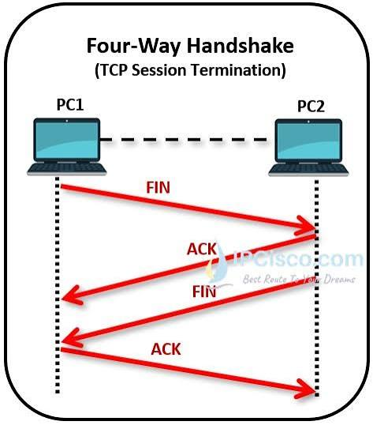

TCP 4-Way Termination Handshake
- Step 1: Active Close (FIN)
  - Action: The client sends a FIN packet to the server.
  - Purpose: The client signals that it has no more data to send and wants to close its side of the connection.
  - State: The client enters the FIN-WAIT-1 state.
- Step 2: Close Acknowledgment (ACK)
  - Action: The server responds with an ACK packet.
  - Purpose: The server confirms it received the client's close request. The connection enters a half-closed state, meaning the client can no longer send data, but it can still receive data if the server has remaining files to transfer.
  - State: The client moves to FIN-WAIT-2, and the server enters CLOSE-WAIT.
- Step 3: Passive Close (FIN)
  - Action: The server sends its own FIN packet to the client.
  - Purpose: Once the server finishes transmitting all of its remaining data, it signals to the client that it is ready to fully close its side of the communication channel.
  - State: The server enters the LAST-ACK state.
- Step 4: Final Acknowledgment (ACK)
  - Action: The client sends a final ACK packet back to the server.
  - Purpose: The client confirms receipt of the server's close request. The server goes straight to CLOSED. The client enters a temporary TIME-WAIT safety delay (typically 2 minutes) to ensure this final packet safely arrived and to catch any lingering packets on the network before fully shutting down.
  - State: After the delay, the client moves to CLOSED.

TCP flags
The 6 Core TCP Flags
- SYN (Synchronize): Used during the initial three-way handshake to synchronize sequence numbers and establish a connection.
- ACK (Acknowledgment): Confirms that data packets or a SYN/FIN status have been successfully received. The acknowledgment number states the next expected byte.
- FIN (Finish): Requests a graceful, four-way termination of the connection after all data transmission is complete.
- RST (Reset): Abruptly aborts and tears down a connection due to an error, unexpected packet, or closed port.
- PSH (Push): Tells the receiving end to deliver data immediately to the application instead of buffering it.
- URG (Urgent): Marks specific data as high priority so the receiver processes it immediately, utilizing the 10-bit/16-bit urgent pointer.

HTTP status codes
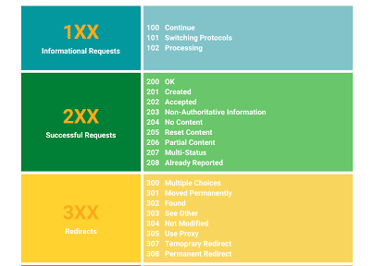

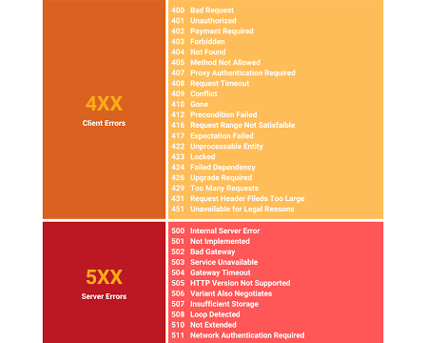

HTTP request methods
GET (Read)
The GET method is strictly used to request and retrieve data from a specific resource on a server without making any changes to it. When you perform a search, click a link, or type a web address into your browser, you are executing a GET request. Because its only job is to read data, it is classified as a "safe" and "idempotent" method, meaning that running the same GET request multiple times will always yield the same result and will never alter or corrupt the server's database.
To send parameters or filters to the server, a GET request appends the data directly to the end of the URL as a query string (for example, ?search=shoes&size=10). Because this data is completely visible in the browser's address bar, GET requests should never be used for sensitive information like passwords. Furthermore, since the data is embedded in the URL, these requests are limited by browser URL length restrictions, but they gain the distinct advantage of being completely cacheable, shareable, and bookmarkable.

POST (Create)
The POST method is designed to submit and send data to a server so it can be processed, typically resulting in the creation of a new resource or a change in the server's state. Whenever you sign up for a new account, upload a photo, or complete an online checkout, your browser utilizes a POST request to send that new information to the database. It is neither safe nor idempotent; submitting the exact same POST request twice (like refreshing a page after buying an item) can result in duplicate actions, such as creating two accounts or charging a credit card twice.
Unlike GET, a POST request packages its data securely inside the hidden request body rather than appending it to the URL. This makes the URL look perfectly clean and allows you to safely transmit sensitive data like credit card numbers or login credentials without exposing them in the history log. Because the data travels in the body, POST requests have no size limitations, making them the ideal choice for uploading heavy files like videos, PDFs, or massive JSON payloads.

Network Classes
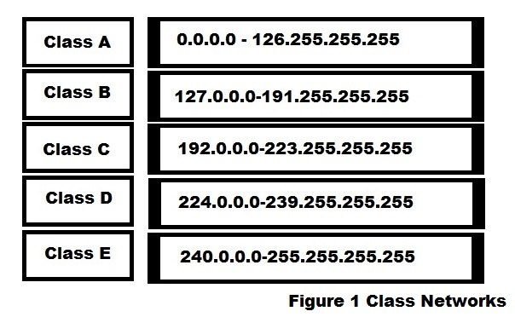

Overview of IPv4 Network Classes
Class A
- First Octet Range: 1.0.0.0 to 127.0.0.0 (First bit is 0)
- Default Subnet Mask: 255.0.0.0 (/8)
- Structure: 8 bits for Network ID, 24 bits for Host ID
- Usage: Large-scale networks (supports ~16 million hosts
Class B
- First Octet Range: 128.0.0.0 to 191.255.0.0 (First two bits are 10)
- Default Subnet Mask: 255.255.0.0 (/16)
- Structure: 16 bits for Network ID, 16 bits for Host ID
- Usage: Medium-to-large corporate or institutional networks (supports 65,534 hosts)
Class C
- First Octet Range: 192.0.0.0 to 223.255.255.0 (First three bits are 110)
- Default Subnet Mask: 255.255.255.0 (/24)
- Structure: 24 bits for Network ID, 8 bits for Host ID
- Usage: Small local area networks (LANs), supporting up to 254 hosts
Class D
- First Octet Range: 224.0.0.0 to 239.255.255.255 (First four bits are 1110)
- Structure: Does not use Network/Host divisions
- Usage: Reserved strictly for multicast communication
Class E
- First Octet Range: 240.0.0.0 to 255.255.255.255 (First four bits are 1111)
- Structure: Undivided
- Usage: Reserved for experimental, research, and future use
Classful addressing was phased out in 1993 with the introduction of Classless Inter-Domain Routing (CIDR) and Variable Length Subnet Masking (VLSM). Modern networks use flexible prefix lengths instead of rigid A, B, and C boundaries, though the legacy terminology is still referenced in foundational networking and documentation. nnnnnnnnnnnnnnnnnnnnnn
IP logger
An IP logger (often called an IP grabber) is a digital tool used to capture and record the IP addresses and technical details of users who interact with a specific link, image, or tracking pixel.



